**Anisha Jain**

**Self-Work Report**

**Week 1**

**Status**

**Implemented work**

* Discussed the attributes to be used for user input.
* Read about how to implement React JS forms.
* Created a single form frontend using React JS.
* Read about REST API and Django.
* Discussion about Database Schema with all:

1. First Name
2. Last Name
3. Email ID
4. Contact No.
5. Store Address
6. Location – (City, State)
7. Type of Store (Gym, Departmental Store, Pharmacy etc.)
8. Size of Store
9. No. of working employees
10. No. of expected Customers in store/day
11. Services you want to offer (Pickup/Delivery/Return/All)
12. Password

Single page frontend

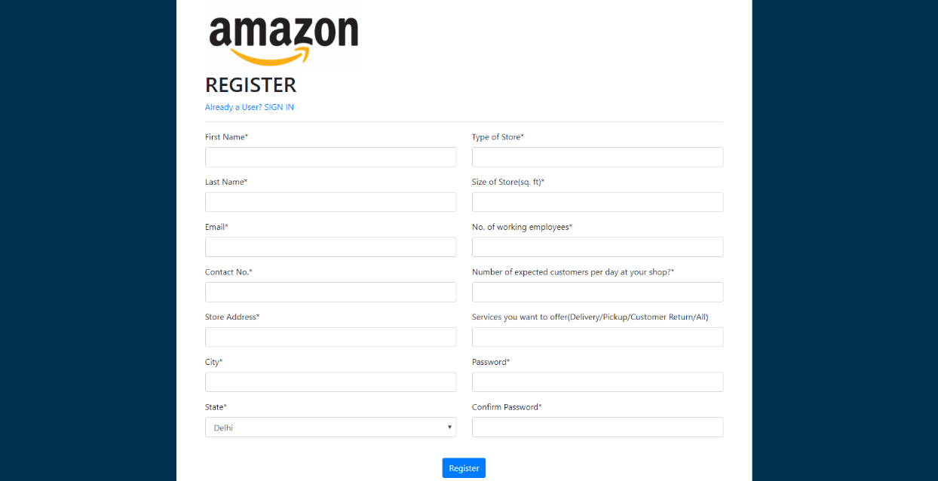

**In Progress**

* Connection of frontend with backend for getting an end-to-end workflow

**Week 2**

**Implemented work**

* As discussed converted the single page frontend to multipage frontend.
* Discussed upon and finalized some key parameters to be used for prediction.

1. Number of customers visiting the shop/sq ft
2. Number of employees in a shop/sq ft
3. Area/ size of shop
4. Google rating
5. Density of that area

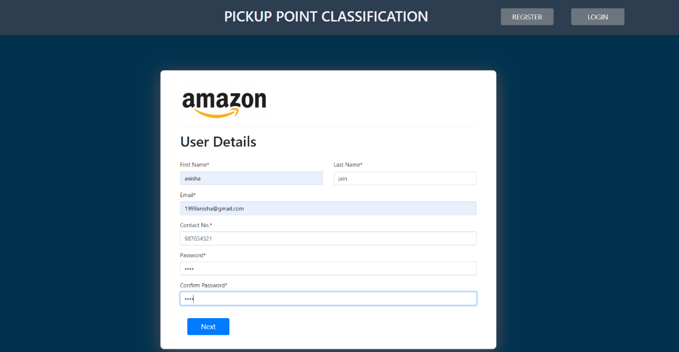

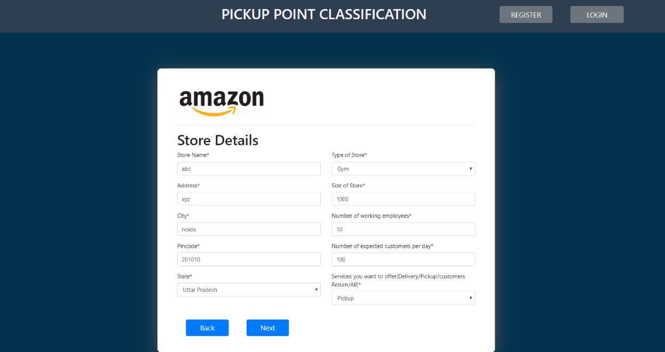

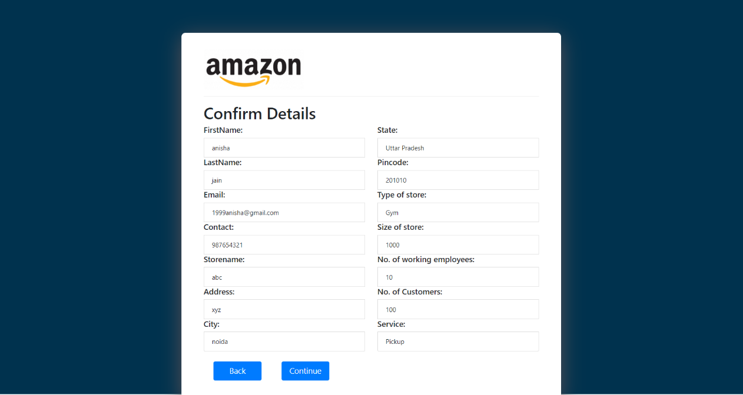

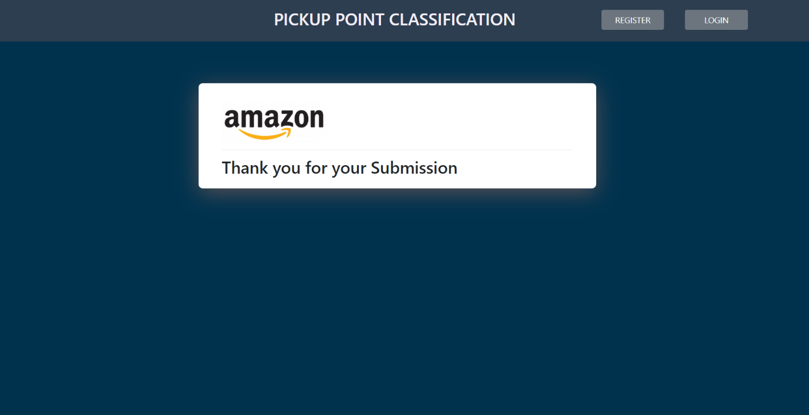

**References**

<https://css-tricks.com/the-magic-of-react-based-multi-step-forms/>

<https://www.digitalocean.com/community/tutorials/how-to-create-multistep-forms-with-react-and-semantic-ui>

* Designed Low Level diagram of our project.

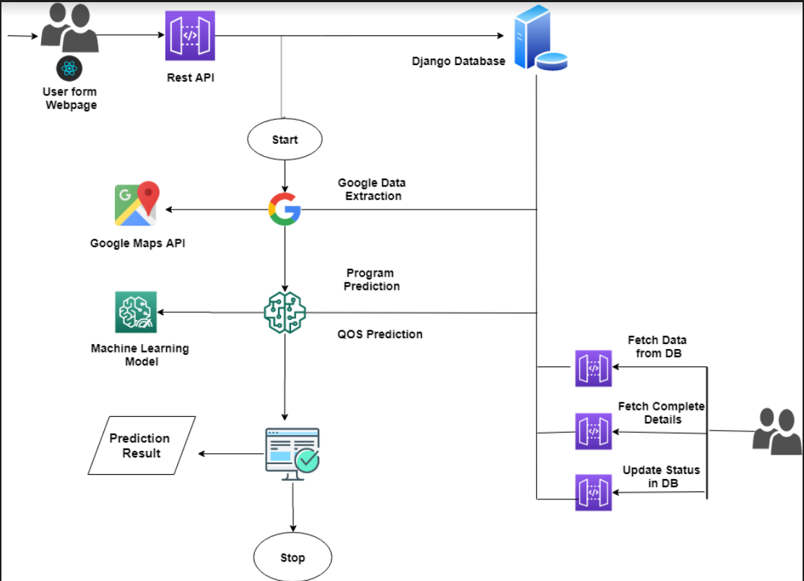

**Week 3**

**Implemented Work**

* Applied validation to multipage Form.
* Read about various algorithms for multilabel classification and there implementation .
* Multiclass classification required for four programs-

1. 3P
2. Locker
3. I Have Space(HIS)
4. Helix

* Researched on the following algorithms :

1. Logistic Regression
2. XG Boost
3. Random forest
4. Naïve bayes

* Read about google maps API and how to implement it.

**References**

<https://towardsdatascience.com/logistic-regression-detailed-overview-46c4da4303bc>

<https://towardsdatascience.com/https-medium-com-vishalmorde-xgboost-algorithm-long-she-may-rein-edd9f99be63d>

<https://medium.com/@Synced/how-random-forest-algorithm-works-in-machine-learning-3c0fe15b6674>

<https://www.geeksforgeeks.org/naive-bayes-classifiers/>

**Week 4**

**Implemented Work**

* Created a Login Page.
* Read about Routing for switching between Register and Login.
* Created a Navigation Bar for Routing between Register and Login.
* Implemented Routing between Register and login.

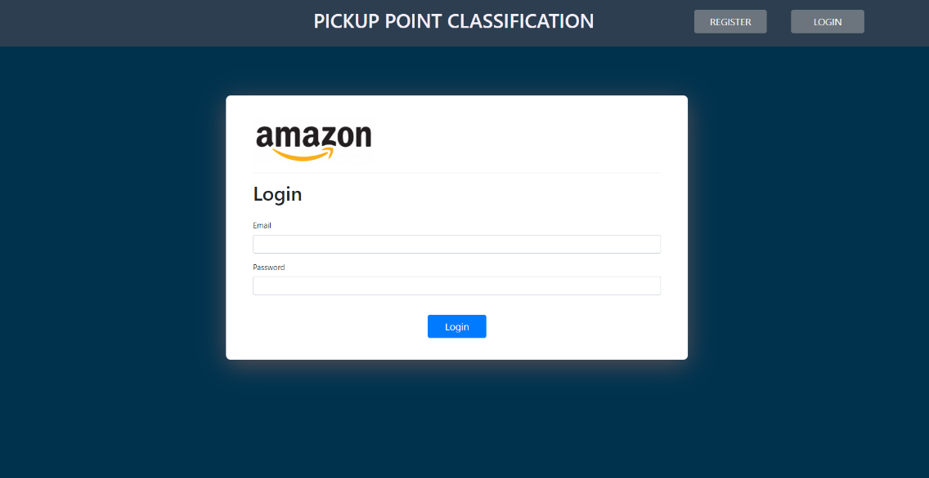

**References**

<https://medium.com/javascript-in-plain-english/routing-and-navigation-in-react-cffc26e8a389>

<https://www.youtube.com/watch?v=5pt_igBTCsI>

**Week 5**

**Flow Diagram**

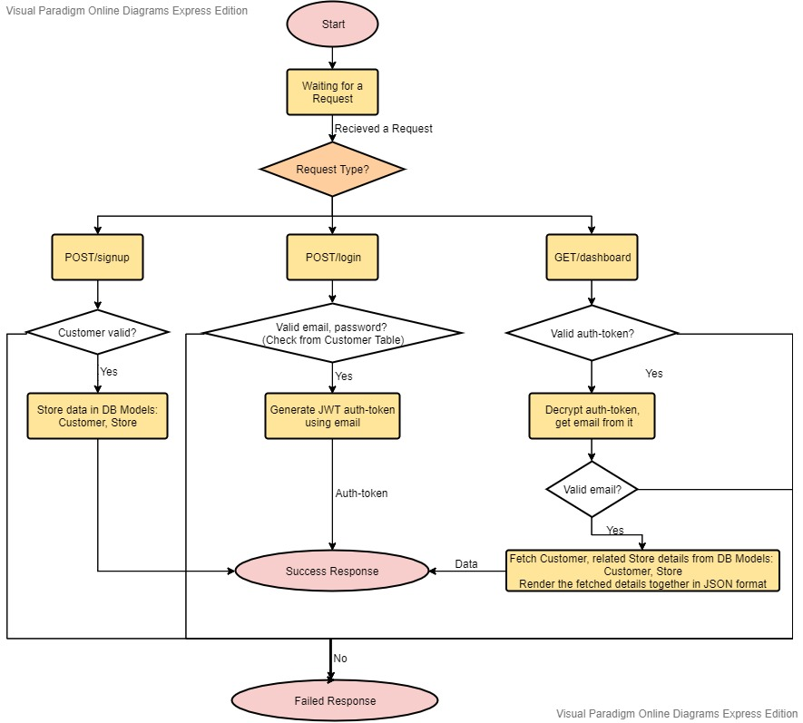

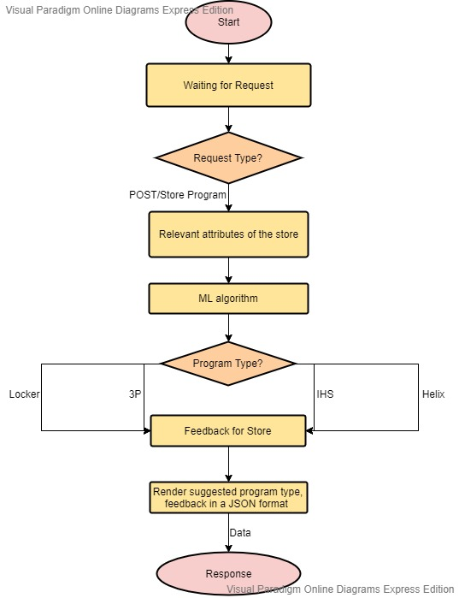

**Implemented Work**

* Updated the Dropdown Menu.
* Fixed some minor bugs in frontend
* Testing of end-to-end flow of the Model built till now.
* Tried deploying ML model at server side.
* Created Flow Diagrams along with Shubhangi Aggarwal.

**Week 6**

**Implemented Work**

* Created a new Database for training of ML model(1600 rows) as previous Database was not giving good results.
* Database Attributes:

1. Store Type – Gym, Restaurants, Grocery, Departmental, Store, Movie theatre, Bank, Pharmacy, Lifestyle Store
2. Owned/Rented
3. City – Considered some cities from Delhi, Maharashtra, Gujarat, Punjab,

Uttar Pradesh

1. Rating – Random
2. Address – Random
3. Total sq ft – Random
4. Employees – Random
5. DPMO – Random
6. Programs and its Value

* Updated changes in frontend as per the database.
* Cleaned code – removed unused components.
* Testing of final flow of the application.
* Updated Heading in Nav.js.

[Frontend Work Done]

|  |
| --- |
|  |
|  |
|  |
|  |
|  |
|  |
|  |
|  |